Ansible Task-4

- Write a single ansible playbook which will install apache and nginx. Note: Playbook should not be hardcoded and pass the variables from different file.
- Ansible playbook to create 10 different directories with minimal code and directory names should be passed as variables.
- Ansible playbook to copy ssh-keygen from master to worker nodes. Note: a)Provision new 3 ec2 machines, one master and two worker nodes. b)Create common user called ansadm and provide sudo priviliges on 3 ec2 instances. c)Create ssh-keygen in master and your playbook should copy the keygen making it password less authentication.
- Ansible playbook to inject ansible vault variables.

Task 1 — Install Apache and Nginx using variables
Objective: Install both web servers on your worker nodes using one playbook, with variables stored in a separate file instead of hardcoding package names in the playbook.
Directory structure
On our Ansible master, inside ~/ansible-lab/
ansible-lab/
├── inventory.ini
├── install_webservers.yml
└── webservers_vars.yml
Because your workers run Ubuntu, we'll use the package names apache2 and nginx. Both services can run on the same machine because Apache defaults to port 80 and Nginx also defaults to port 80, so we'll need to account for that port conflict.
For this installation task, we'll install both packages but only start Nginx by default. Apache can be started after configuring a different port, or we can configure Nginx to use a different port if both must run simultaneously.

Step 1: Create the variables file
Run:
cd ~/ansible-lab
nano webservers_vars.yml
Add:
---
web_packages:
- apache2
- nginx
Save with Ctrl+O, Enter, then Ctrl+X.
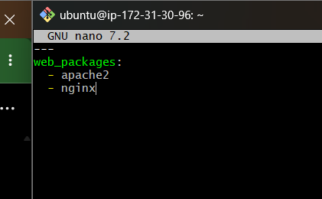

Step 2: Create the playbook
nano install_webservers.yml
Add this complete playbook:
---
- name: Install Apache and Nginx
hosts: workers
become: yes
gather_facts: yes

vars_files:
- webservers_vars.yml

tasks:
- name: Install web server packages
ansible.builtin.apt:
name: "{{ web_packages }}"
state: present
update_cache: yes
Here, vars_files loads the package names from the separate YAML file. The playbook itself doesn't hardcode either package name.
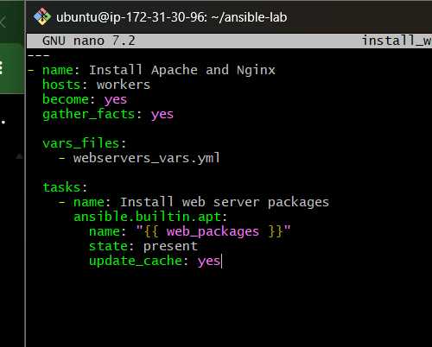

Step 3: Validate and run
Check the syntax:
ansible-playbook -i inventory.ini --syntax-check install_webservers.yml
Run the playbook:
ansible-playbook -i inventory.ini install_webservers.yml
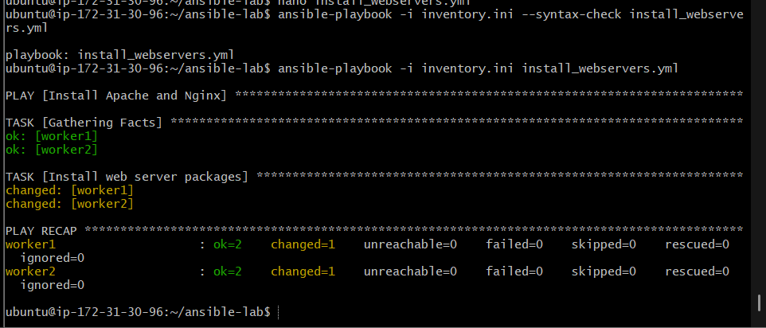

Step 4: Verify installation on both workers
ansible workers -i inventory.ini -b -m shell \
-a "dpkg-query -W -f='\${Package} \${Status}\n' apache2 nginx"
Expected output should show both packages as install ok installed on each worker.
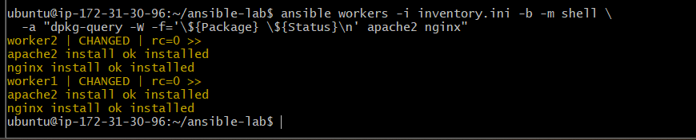

Task 2 — Create 10 different directories using Ansible variables
Objective: Create 10 directories on both worker nodes using a single playbook. Store the directory names in a separate variables file to keep the playbook short and reusable.

Step 1: Create the variables file
On your Ansible master, run:
cd ~/ansible-lab
nano directories_vars.yml
Add these directory names:
---
directory_path: /opt/ansible-lab

directory_names:
- dev
- test
- prod
- staging
- logs
- backup
- scripts
- config
- reports
- monitoring
Save with Ctrl+O, press Enter, then Ctrl+X.
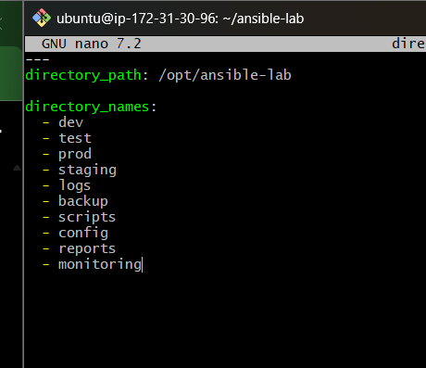

Step 2: Create the playbook
nano create_directories.yml
Paste this complete playbook:
---
- name: Create 10 directories on worker nodes
hosts: workers
become: yes
gather_facts: false

vars_files:
- directories_vars.yml

tasks:
- name: Create directories from the variables list
ansible.builtin.file:
path: "{{ directory_path }}/{{ item }}"
state: directory
owner: ubuntu
group: ubuntu
mode: "0755"
loop: "{{ directory_names }}"
Save and exit.
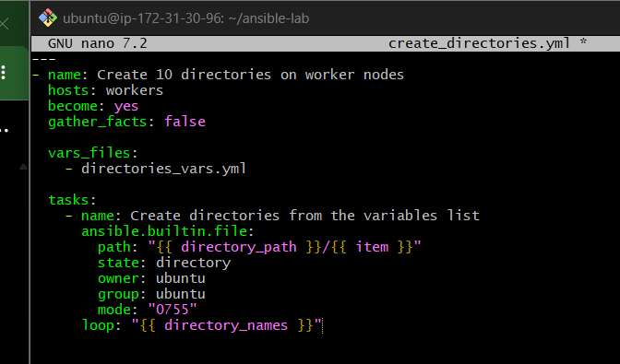

Step 3: Validate the playbook
ansible-playbook -i inventory.ini --syntax-check create_directories.yml
Expected output:
playbook: create_directories.yml

Step 4: Execute the playbook
ansible-playbook -i inventory.ini create_directories.yml

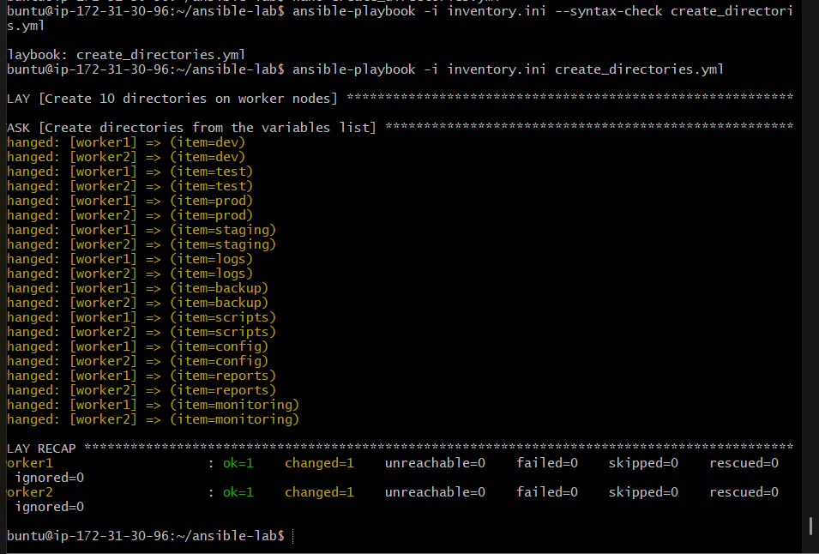
The playbook creates the 10 directories under /opt/ansible-lab/ on both workers. Since it uses become: yes, it can create the parent directory under /opt.

Step 5: Verify the directories
ansible workers -i inventory.ini -b -m shell \
-a "find /opt/ansible-lab -mindepth 1 -maxdepth 1 -type d | sort"
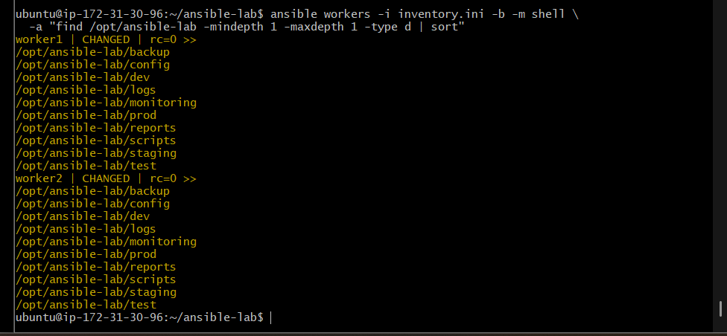
You should see all 10 directory names on each worker.
To count them:
ansible workers -i inventory.ini -b -m shell \
-a "find /opt/ansible-lab -mindepth 1 -maxdepth 1 -type d | wc -l"
Expected count on each worker:
10
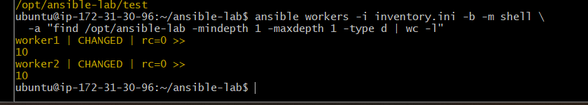

How it works
- vars_files loads directory names from directories_vars.yml.
- loop iterates through all 10 names.
- state: directory creates a directory if it doesn't exist.
- mode: "0755" gives the owner read/write/execute permissions and others read/execute permissions.

Task 3 — Provision 3 EC2 instances and configure passwordless SSH with Ansible
Objective: Create a new Ansible environment with one master and two workers, create a common ansadm user on all three machines, grant sudo privileges, and configure SSH key-based authentication so ansadm on the master can connect to both workers without a password.
We'll do this in stages and verify each one before continuing.
New EC2 — Ansible Master
User: ansadm
Generate SSH key pair
Worker 1
User: ansadm
Worker 2
User: ansadm
The master's public key will be installed on both workers.

Stage 1 — Provision three new EC2 instances
Since you already have an older Ansible lab, keep these new machines separate. Use us-east-1, Ubuntu 24.04, and t3.micro if available and suitable for your account.

Step 1: Check your AWS permissions
Run this on your current AWS-connected Ansible master:
aws sts get-caller-identity
Check that your IAM role can launch instances, create or use security groups, and inspect EC2 resources. If permissions are insufficient, resolve that before proceeding.

Step 2: Identify a suitable subnet and security group
Run:
aws ec2 describe-subnets \
--region us-east-1 \
--query 'Subnets[*].[SubnetId,VpcId,AvailabilityZone,State]' \
--output table
aws ec2 describe-security-groups \
--region us-east-1 \
--query 'SecurityGroups[*].[GroupId,GroupName,VpcId]' \
--output table
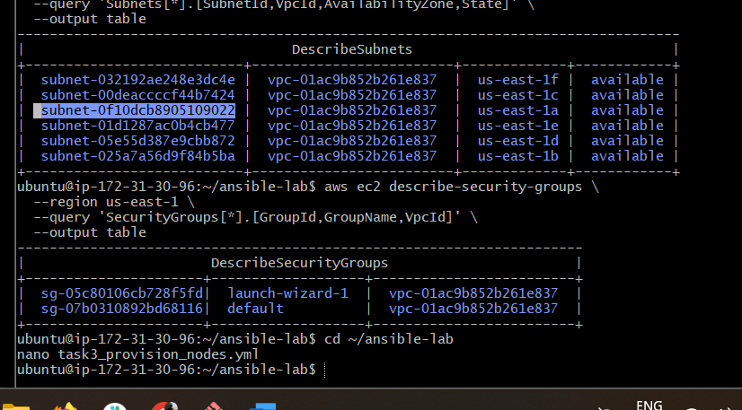
Choose a subnet and security group from the same VPC. The security group must permit SSH (TCP port 22) from the master to the workers. Restrict SSH to trusted sources rather than opening it to the whole internet.

Step 3: Create the provisioning playbook
We'll use the existing AWS key pair ansiblekey for the initial SSH access. Make sure its private key is available on your current control machine, and that the new instances will be reachable from it.
Create the playbook:
cd ~/ansible-lab
nano task3_provision_nodes.yml
Paste this template:
---
- name: Provision three EC2 instances for the Ansible lab
hosts: localhost
connection: local
gather_facts: false

vars:
aws_region: us-east-1
ami_id: "ami-0fa5967347d08d2df"
instance_type: t3.micro
key_name: "ansiblekey"
subnet_id: "REPLACE_WITH_SUBNET_ID"
security_group_id: "REPLACE_WITH_SECURITY_GROUP_ID"

tasks:
- name: Launch master and two worker nodes
amazon.aws.ec2_instance:
name: "{{ item }}"
region: "{{ aws_region }}"
image_id: "{{ ami_id }}"
instance_type: "{{ instance_type }}"
key_name: "{{ key_name }}"
vpc_subnet_id: "{{ subnet_id }}"
security_group: "{{ security_group_id }}"
network:
assign_public_ip: true
state: running
wait: true
loop:
- ansible-master-new
- ansible-worker1-new
- ansible-worker2-new
register: provisioned_nodes

- name: Display instance details
ansible.builtin.debug:
var: provisioned_nodes
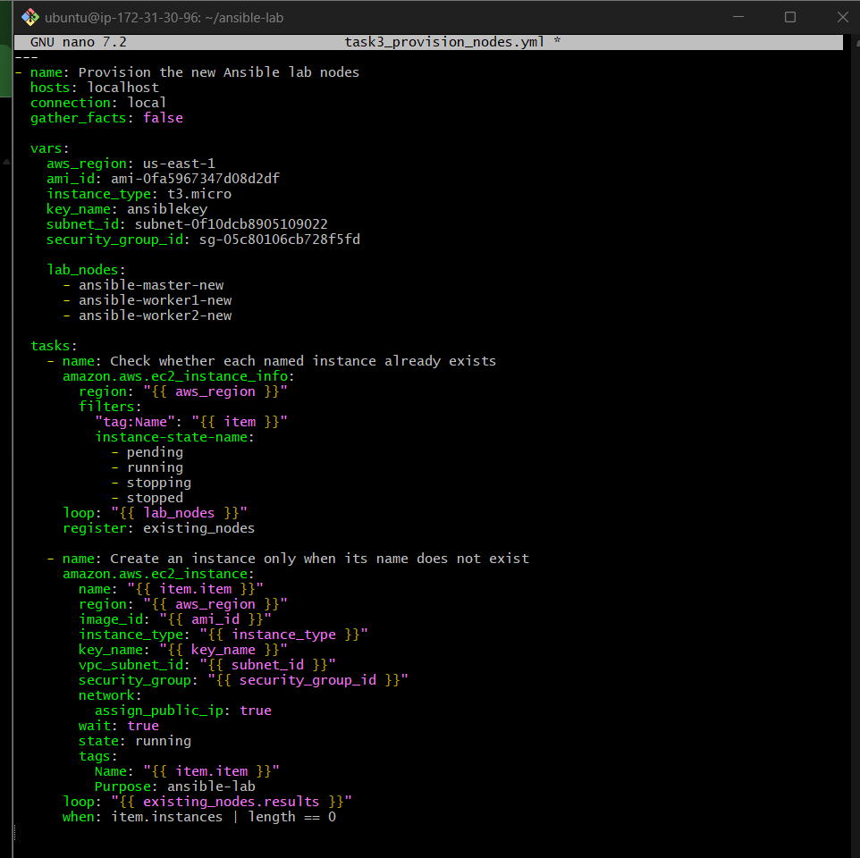
This uses a loop to request three instances. Do not execute it while the subnet and security-group placeholders remain. Also, confirm that the chosen subnet supports public IP assignment and that your security group permits only the required SSH access.

Step 4: Validate before launching
First, confirm the AWS collection is installed:
ansible-galaxy collection list amazon.aws
Then check the playbook syntax:
ansible-playbook --syntax-check task3_provision_nodes.yml
Expected result:
playbook: task3_provision_nodes.yml
If the collection is missing, install it:
ansible-galaxy collection install amazon.aws

Step 5: Launch the instances
Only after the syntax check succeeds, run:
ansible-playbook task3_provision_nodes.yml
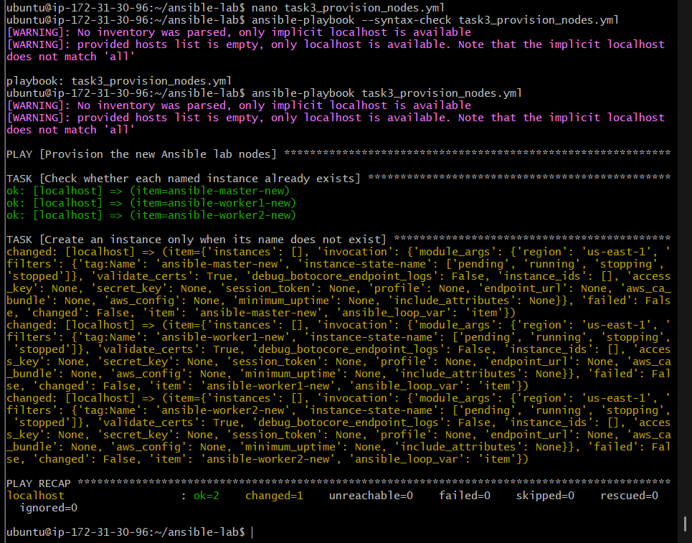
This creates or reconciles the three named instances.

Step 6: Verify the instances
aws ec2 describe-instances \
--region us-east-1 \
--filters \
"Name=tag:Purpose,Values=ansible-lab" \
"Name=instance-state-name,Values=pending,running,stopped" \
--query 'Reservations[].Instances[].{Name:Tags[?Key==`Name`]|[0].Value,InstanceId:InstanceId,State:State.Name,PrivateIP:PrivateIpAddress,PublicIP:PublicIpAddress}' \
--output table
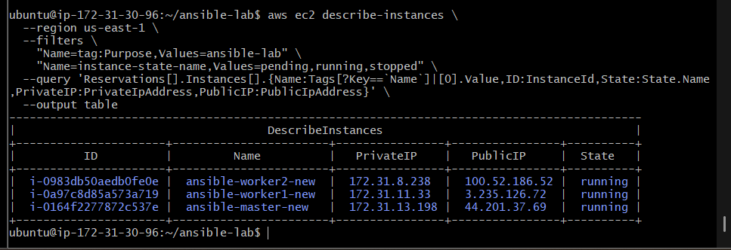

Step 7: Create a new inventory
On your existing Ansible controller (172.31.30.96), run:
cd ~/ansible-lab
nano task3_inventory.ini
Paste:
[new_master]
ansible-master-new ansible_host=44.201.37.69

[new_workers]
ansible-worker1-new ansible_host=3.235.126.72
ansible-worker2-new ansible_host=100.52.186.52

[new_nodes:children]
new_master
new_workers

[new_nodes:vars]
ansible_user=ubuntu
ansible_ssh_private_key_file=/home/ubuntu/ansiblekey.pem
ansible_ssh_common_args='-o StrictHostKeyChecking=accept-new'
Save and exit.

Step 8: Test SSH connectivity
Run:
ansible -i task3_inventory.ini new_nodes -m ansible.builtin.ping
Expected result for all three hosts:
"ping": "pong"
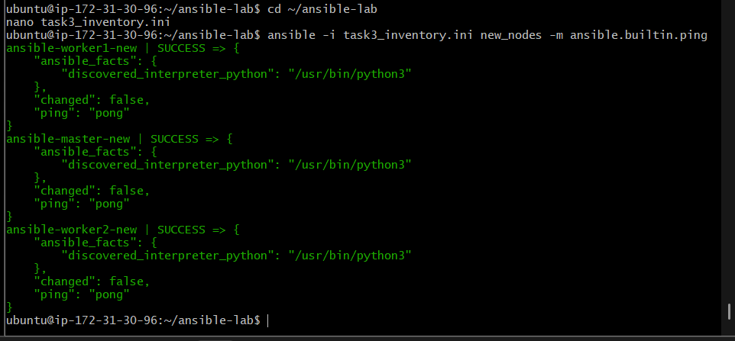

Step 9: Create the ansadm user
On your existing Ansible controller, create a playbook:
nano task3_create_ansadm.yml
Paste this complete playbook:
---
- name: Create ansadm user with sudo privileges
hosts: new_nodes
become: true
gather_facts: false

tasks:
- name: Create ansadm user
ansible.builtin.user:
name: ansadm
comment: Common Ansible administration user
shell: /bin/bash
create_home: true
state: present

- name: Configure passwordless sudo for ansadm
ansible.builtin.copy:
dest: /etc/sudoers.d/ansadm
content: "ansadm ALL=(ALL:ALL) NOPASSWD:ALL\n"
owner: root
group: root
mode: "0440"
validate: "/usr/sbin/visudo -cf %s"

- name: Create SSH directory for ansadm
ansible.builtin.file:
path: /home/ansadm/.ssh
state: directory
owner: ansadm
group: ansadm
mode: "0700"
Save with Ctrl+O, press Enter, and exit with Ctrl+X.
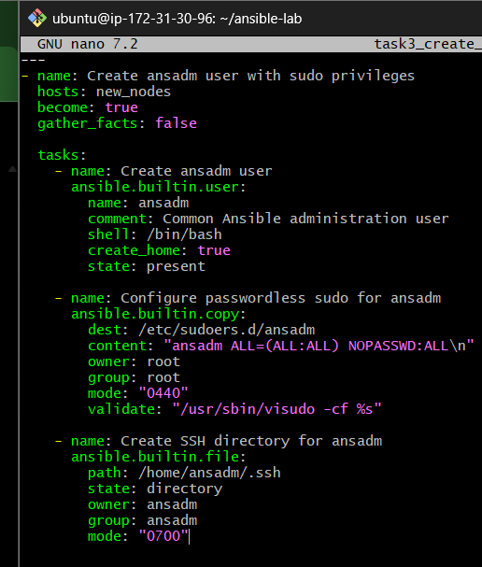
Run the playbook:
ansible-playbook -i task3_inventory.ini task3_create_ansadm.yml

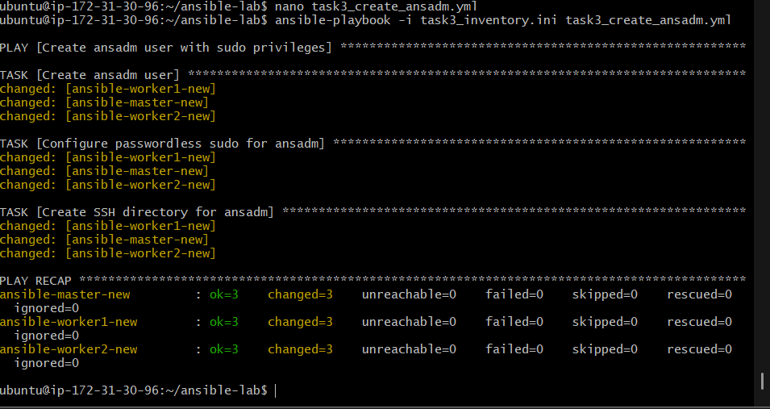

Step 10: Verify the user and sudo privileges
Run:
ansible -i task3_inventory.ini new_nodes -b \
-m ansible.builtin.command \
-a "id ansadm"
Expected output should include uid=... (ansadm) for all three hosts.
Then verify sudo configuration:
ansible -i task3_inventory.ini new_nodes -b \
-m ansible.builtin.command \
-a "visudo -cf /etc/sudoers.d/ansadm"
Expected result on each host:
/etc/sudoers.d/ansadm: parsed OK
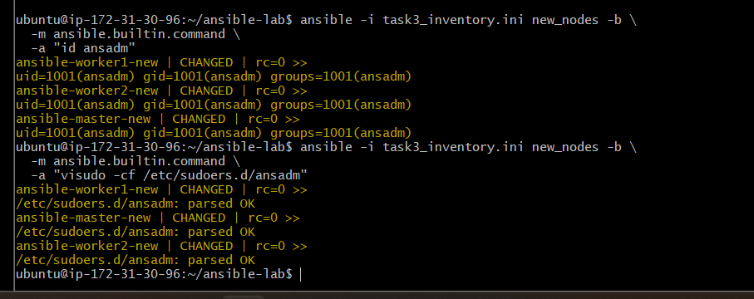

Step 11: Generate an SSH key on the new master
Create a playbook on your current controller:
nano task3_ssh_key.yml
Paste this complete playbook:
---
- name: Generate SSH key on the new Ansible master
hosts: new_master
become: true
gather_facts: false

tasks:
- name: Generate an Ed25519 key pair for ansadm
become_user: ansadm
ansible.builtin.command:
argv:
- ssh-keygen
- -t
- ed25519
- -f
- /home/ansadm/.ssh/id_ed25519
- -N
- ""
args:
creates: /home/ansadm/.ssh/id_ed25519

- name: Read the public key
ansible.builtin.slurp:
src: /home/ansadm/.ssh/id_ed25519.pub
register: ansadm_public_key

- name: Add the public key to both workers
ansible.builtin.authorized_key:
user: ansadm
key: "{{ hostvars['ansible-master-new']['ansadm_public_key']['content'] | b64decode }}"
state: present
delegate_to: "{{ item }}"
loop: "{{ groups['new_workers'] }}"
become: true
Save and exit.

Important correction before running
The public-key distribution task above needs the master’s key registered in host variables before it can be used reliably by delegated worker tasks. Let's use a simpler, reliable two-play approach instead.
Replace the file contents with this version:
---
- name: Generate an SSH key on the new master
hosts: new_master
become: true
gather_facts: false

tasks:
- name: Generate an Ed25519 key pair if absent
ansible.builtin.command:
argv:
- ssh-keygen
- -t
- ed25519
- -f
- /home/ansadm/.ssh/id_ed25519
- -N
- ""
args:
creates: /home/ansadm/.ssh/id_ed25519

- name: Set private key ownership and permissions
ansible.builtin.file:
path: /home/ansadm/.ssh/id_ed25519
owner: ansadm
group: ansadm
mode: "0600"

- name: Set public key ownership and permissions
ansible.builtin.file:
path: /home/ansadm/.ssh/id_ed25519.pub
owner: ansadm
group: ansadm
mode: "0644"

- name: Read the master's public key
ansible.builtin.slurp:
src: /home/ansadm/.ssh/id_ed25519.pub
register: master_public_key

- name: Save the public key on the current controller
ansible.builtin.copy:
content: "{{ master_public_key.content | b64decode }}"
dest: /tmp/ansadm_master.pub
mode: "0644"
delegate_to: localhost
become: false

- name: Authorize the master's key on both workers
hosts: new_workers
become: true
gather_facts: false

tasks:
- name: Install the master's public key for ansadm
ansible.builtin.authorized_key:
user: ansadm
key: "{{ lookup('file', '/tmp/ansadm_master.pub') }}"
state: present
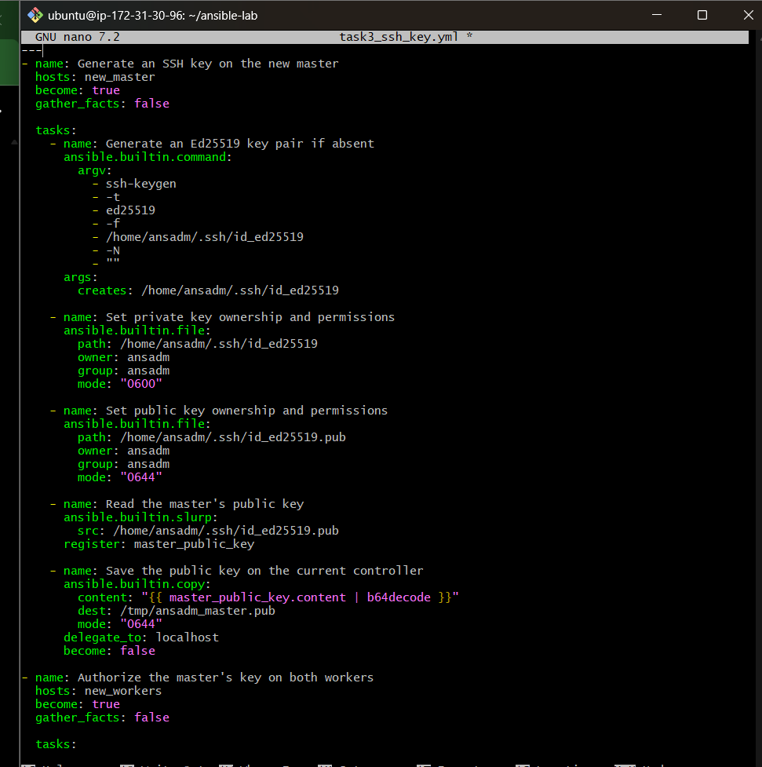

Step 12: Run and verify
First, check syntax:
ansible-playbook -i task3_inventory.ini --syntax-check task3_ssh_key.yml
If it passes, run:
ansible-playbook -i task3_inventory.ini task3_ssh_key.yml
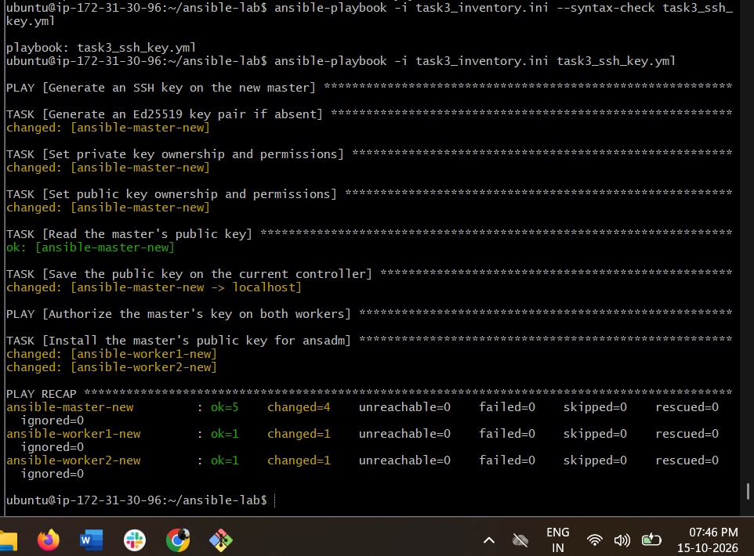
Then verify that the key is installed on both workers:
ansible -i task3_inventory.ini new_workers -b \
-m ansible.builtin.command \
-a "test -f /home/ansadm/.ssh/authorized_keys"

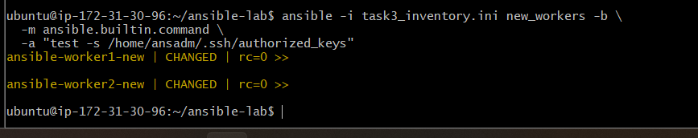

Step 13: Test passwordless SSH

13.1 Connect to the new master
From your current controller (172.31.30.96), run:
ssh -i ~/ansiblekey.pem ubuntu@44.201.37.69
Once logged in to the new master, switch to ansadm:
sudo -iu ansadm
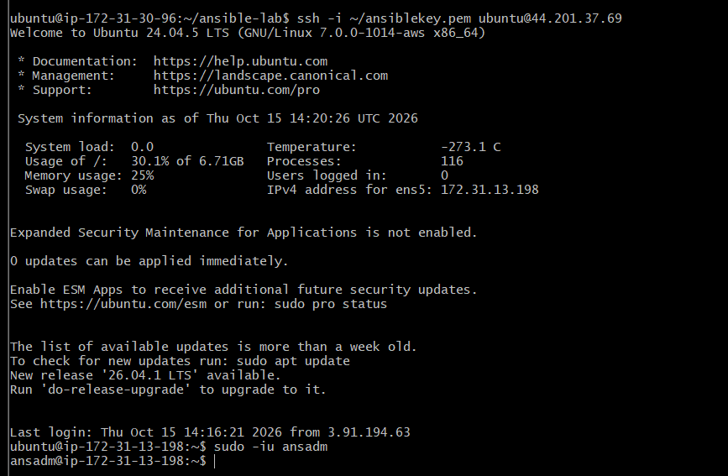

13.2 Connect to Worker 1
On the new master, run:
ssh -o StrictHostKeyChecking=accept-new ansadm@172.31.11.33
Expected result: you log in without being prompted for a password.
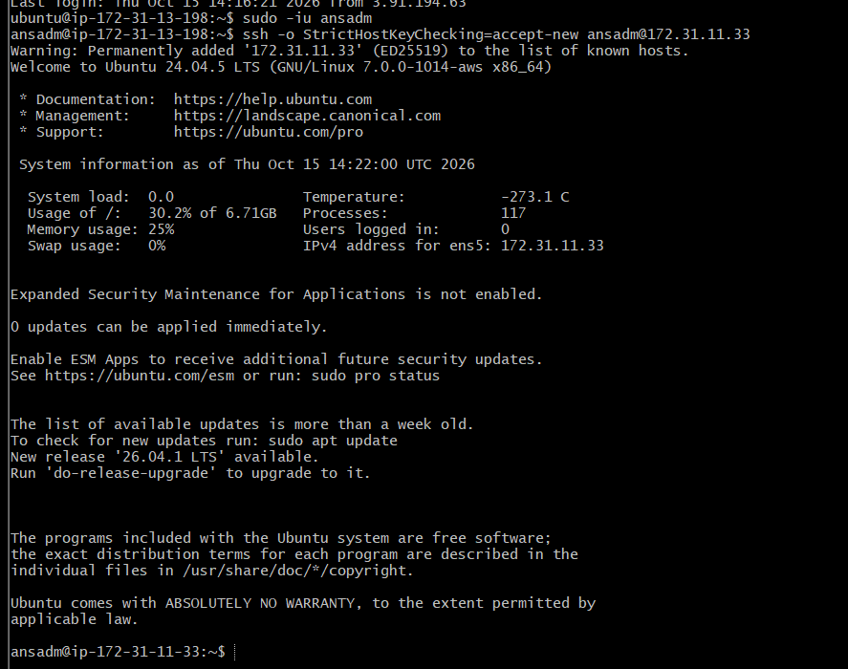
After verifying, exit the worker:
Exit

13.3 Connect to Worker 2
ssh -o StrictHostKeyChecking=accept-new ansadm@172.31.8.238
Again, you should connect without a password prompt. Then return to the new master:
Exit
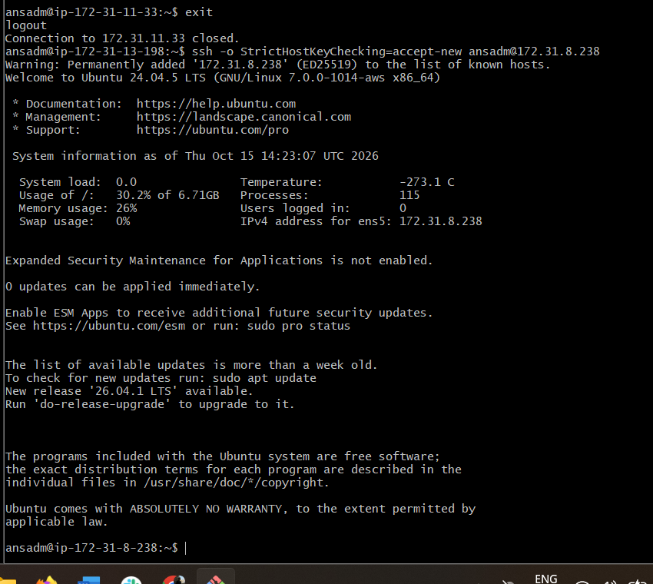

Task 4: Ansible Vault — encrypt sensitive variables and use them in a playbook.

Objective
Learn how to securely store passwords and other sensitive values using Ansible Vault instead of writing them in plain text.
Encrypted variables file
secrets.yml
Ansible Vault
Encrypts sensitive variables with a Vault password
Playbook
Uses the decrypted variables at runtime

Step 1: Create a working directory
On your existing Ansible controller (172.31.30.96), run:
cd ~/ansible-lab
mkdir -p task4-vault
cd task4-vault
Check whether Ansible Vault is available:
ansible-vault –version
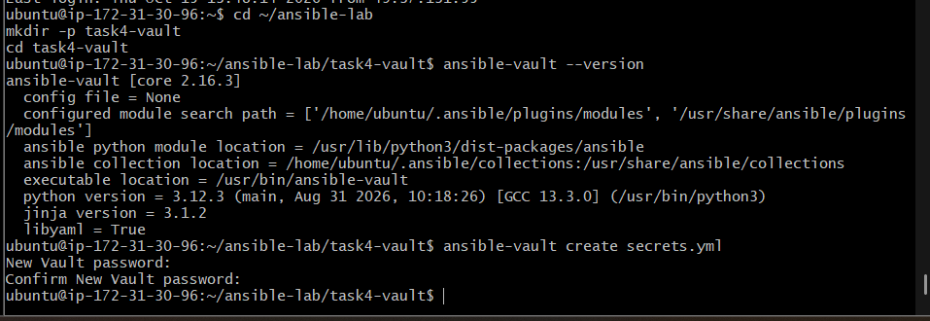
You should see the installed Ansible Vault version.

Step 2: Create an encrypted variables file
Run:
ansible-vault create secrets.yml
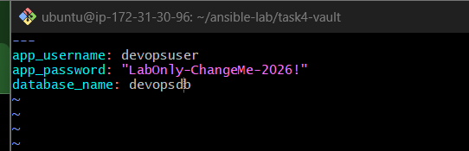
Ansible will ask you to create and confirm a Vault password. Choose a lab password you can remember, but do not share it in this chat.
An editor will open. Enter these sample variables:
---
app_username: devopsuser
app_password: "LabOnly-ChangeMe-2026!"
database_name: devopsdb
Save and exit the editor. Ansible Vault will encrypt the file automatically.
These are dummy lab values, not real credentials.

Step 3: Verify encryption
Run:
cat secrets.yml
The output should begin with something similar to:
$ANSIBLE_VAULT;1.1;AES256
You should not see the variables in readable form.
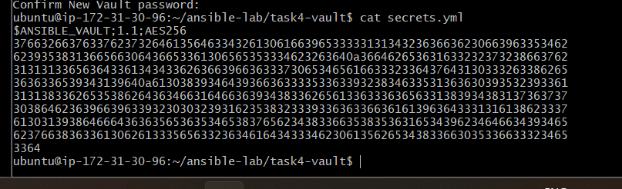

Step 4: Verify that Vault can decrypt the file
Run:
ansible-vault view secrets.yml
Enter your Vault password when prompted. The decrypted YAML should appear.
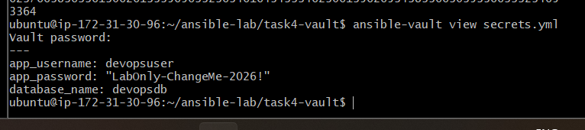

Step 5: Use Vault variables in a playbook
We'll now prove that a playbook can read encrypted variables without displaying the password.

5.1 Create the playbook
You're already in ~/ansible-lab/task4-vault. Run:
nano vault_demo.yml
Paste this complete playbook:
---
- name: Demonstrate Ansible Vault variables
hosts: localhost
connection: local
gather_facts: false

vars_files:
- secrets.yml

tasks:
- name: Display application username
ansible.builtin.debug:
msg: "Application username: {{ app_username }}"

- name: Display database name
ansible.builtin.debug:
msg: "Database name: {{ database_name }}"

- name: Confirm password is loaded without displaying it
ansible.builtin.debug:
msg: "Application password loaded successfully"
when: app_password is defined
Save with Ctrl+O, press Enter, then Ctrl+X.
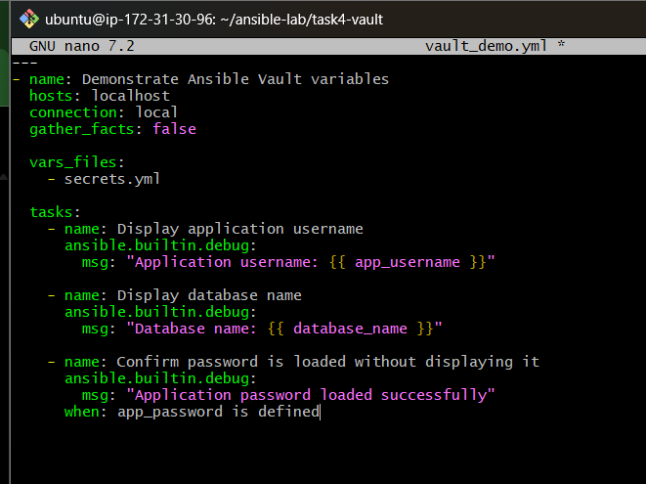

5.2 Run the playbook
ansible-playbook vault_demo.yml --ask-vault-pass
Enter your Vault password when prompted.
Expected output will include:
Application username: devopsuser
Database name: devopsdb
Application password loaded successfully
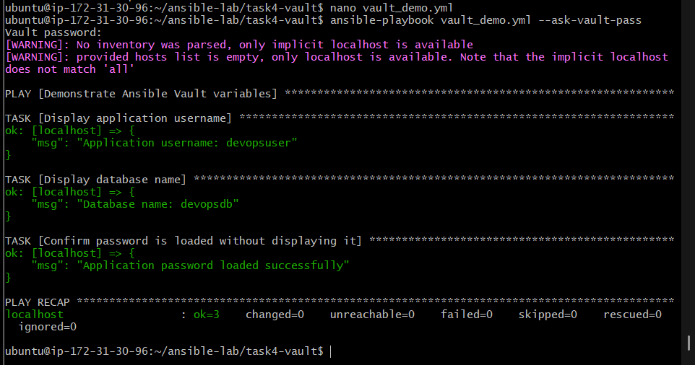
The password itself will not be printed.

5.3 Verify encrypted storage
Run:
head -n 1 secrets.yml
Expected:
$ANSIBLE_VAULT;1.1;AES256
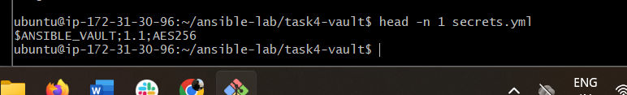
This confirms the file remains encrypted on disk even though Ansible can use its variables at runtime.

